# **ps Commands**

**ps Commands:**

1. Basic ps command.

|  |
| --- |
| ps |

1. The ps -e -f command is a variation of the ps command in Linux that allows you to display a list of all the processes running on your Linux system in a more detailed format. It provides a full-process listing that includes information such as the process owner, parent process ID, and start time.  
     
   Here are some of the key pieces of information that you will be seeing:  
   **UID:** The user ID number of the user who started the process.  
   **PID:** The process ID number that uniquely identifies the process.  
   **PPID:** The parent process ID number.  
   **C:** The processor utilization percentage.  
   **STIME:** The start time of the process.  
   **TTY:** The terminal associated with the process.  
   **TIME:** The amount of CPU time used by the process.  
   **CMD:** The command that was used to start the process.

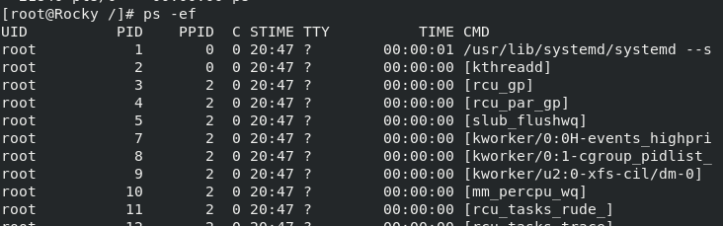

|  |
| --- |
| ps -ef |

1. ps –ef option with specific service or application.

|  |
| --- |
| ps –ef|grep dotnet* |

1. By using the -u option, we can search for processes based on the username.

|  |
| --- |
| ps -u root |